
Ripples of Loss

When we throw a stone in the water, concentric circles ripple toward the water’s edge. This is an example of the ‘Ripple Effect’. One action or event spreads and produces further effects from the same ‘center’. It’s like a contagious smile. Somebody smiles at you and then you smile at somebody else. The feeling of kindness spreads to each person it greets.

We can apply this phenomenon to the vast area of grief and loss. Loss does not only apply to death. It also applies to big changes, identity, relationships, health, etc. The ‘Ripples of Loss’ is an interactive exercise to help you contemplate on the layers of loss that exist in your life and within you. It’s a way of mirroring your reflections so you can further understand the impact the ripple effect has had on your personal experience of loss. With more understanding, you can choose how to move toward liberation of your own suffering while gaining insight and clarity.

In the center circle, write down What or who have you lost? If you’ve had a series of losses, then just pick one main loss for now. You can always use this tool to explore another loss when it’s time.

- In the next circle: what have you lost because of that loss?

- In the next circle: what are you afraid of losing, and where have you been holding yourself back because of those losses?

- In the space around the circle: despite these losses, what remains? -- What have you gained, despite these losses or even perhaps
because of these losses?
- What seems to be growing in the space that these losses used to take up in your life?
- What would you like to carry forward, despite these losses?
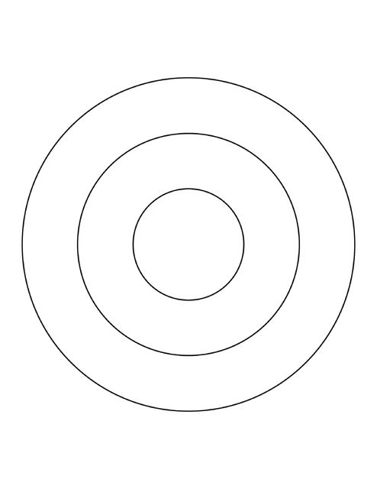
Possible Reflective Prompts
- What was it like to unpack your losses and grief in this way? What feelings came up? What insights came up?

- Were there any losses that surprised you as if you’re recognizing it as a loss for the first time? Do you need to give yourself permission to grieve that?

- Which losses feel invisible to you and/or others?

- What’s the impact on shame when we have invisible losses?

- Which losses - in your ripples and beyond - are high-stigma?

- How do high stigma losses relate to guilt?
- How do high stigma losses affect shame?

- How does shame affect grieving?

- Did any of you feel a bit anxious, guilty, or ashamed sharing your loss after hearing someone else’s loss? What’s the impact when we compare our losses in this way?

- What impact does fear have on how we live after loss?

- What was it like answering the last question about what remains or what has even been gained
- after loss?

Think about this: a single thing you do today can ultimately affect dozens of other people, or even hundreds. This is the ripple effect, and it’s a powerful way to spread positivity—or negativity—in the world.

